| Course Name | ITD 2343 – Object Oriented Programming with C# |
| --- | --- |
| Instructor | Mark L. Pranger |
| Student Name | <Ezequiel Barrientos> |
| Due date | <9/29/25e> |
| Grade | <grade earned here> |
| Grading Comments | <instructor comments here> |

### 1. Completed form in Design view

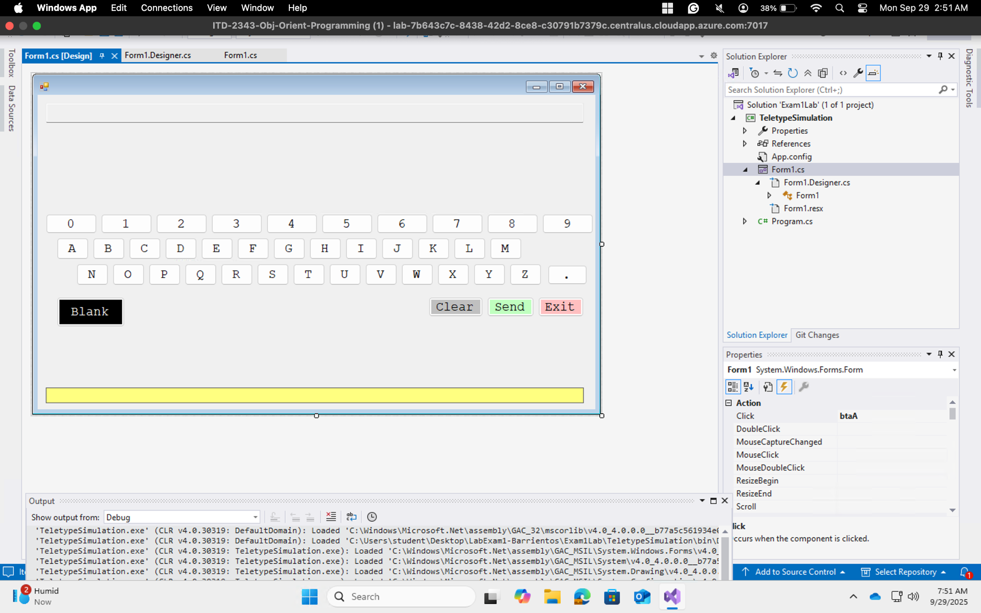

### 2. Completed form running (initial state)

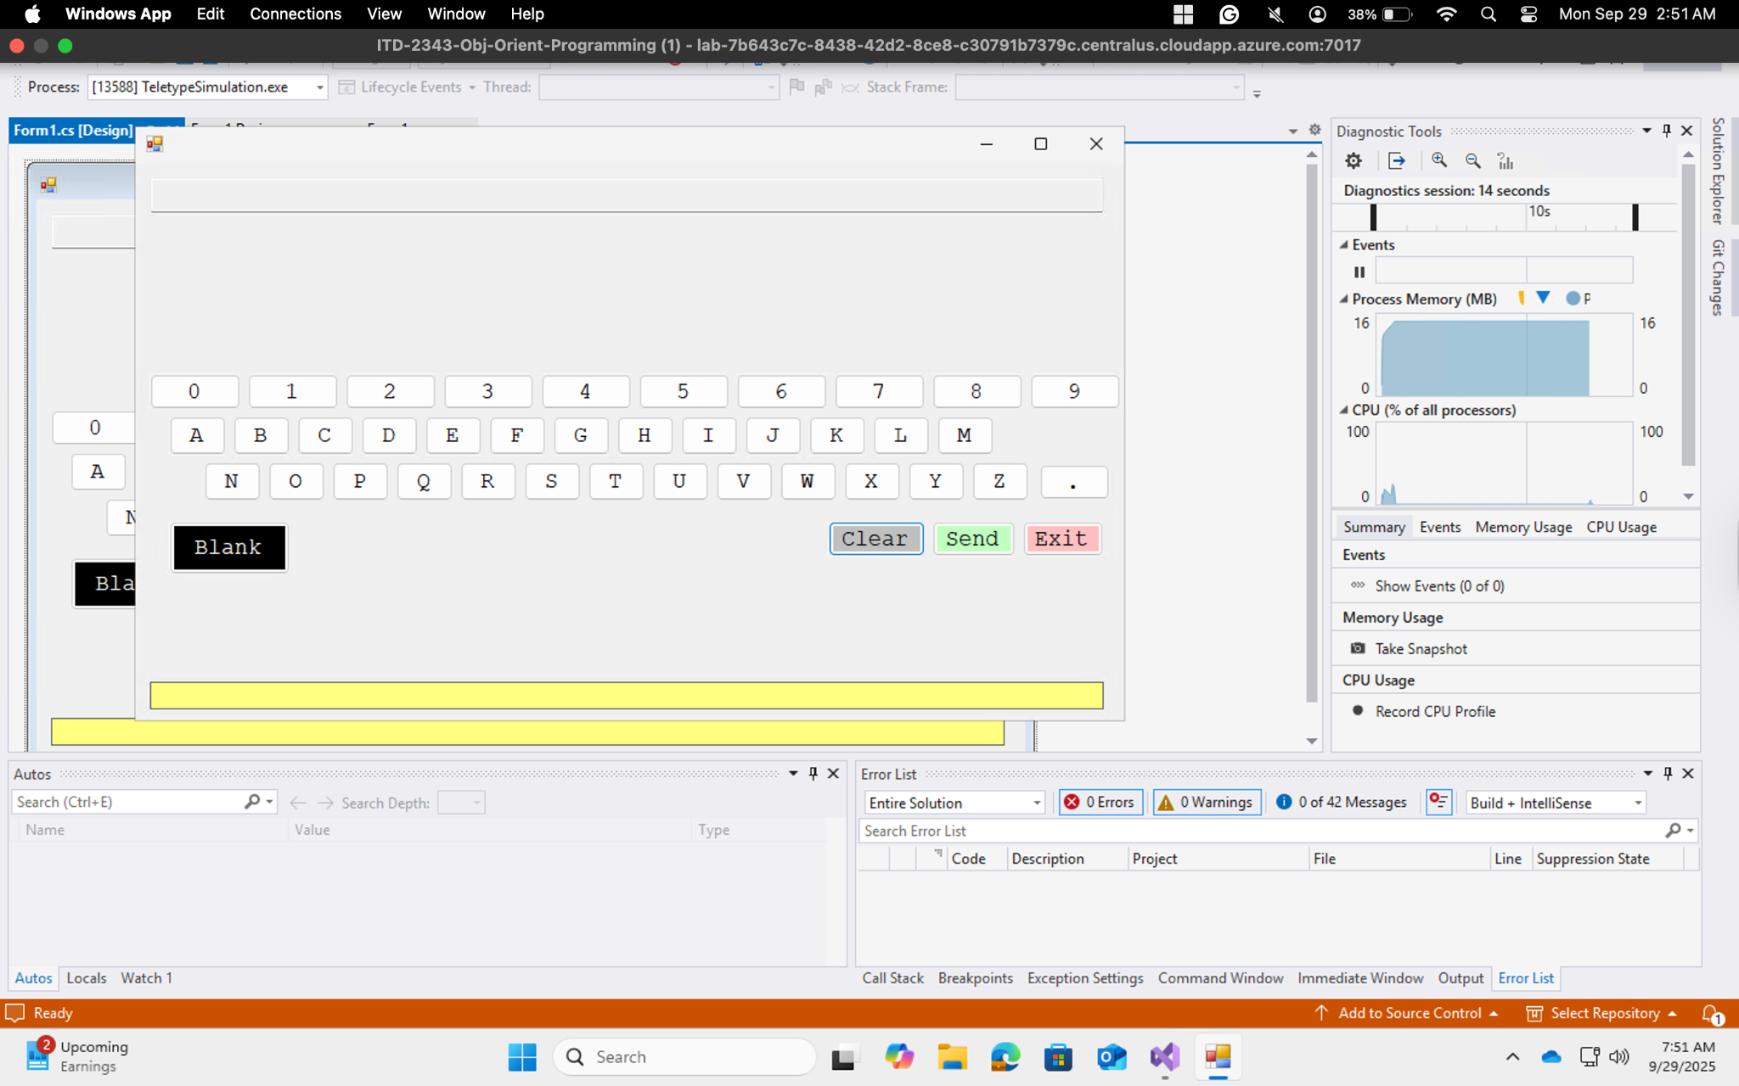

### 3. Partial message typed

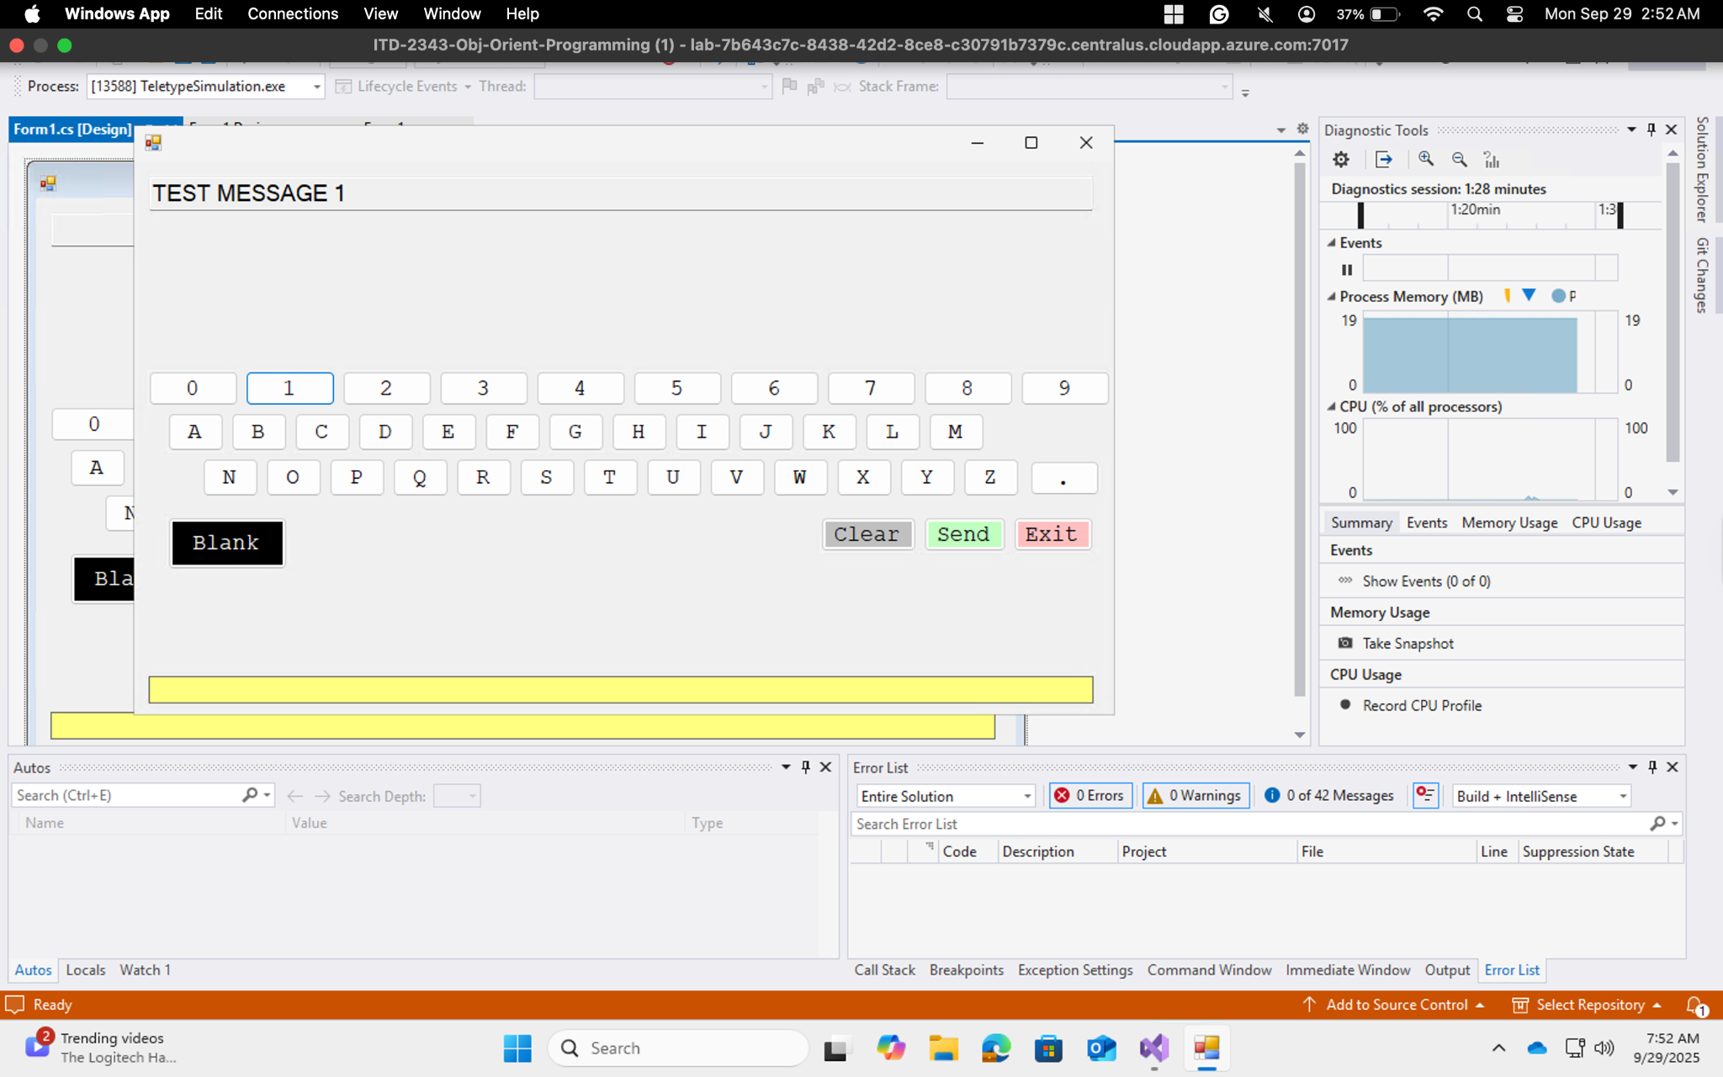

### 4. Completed message typed

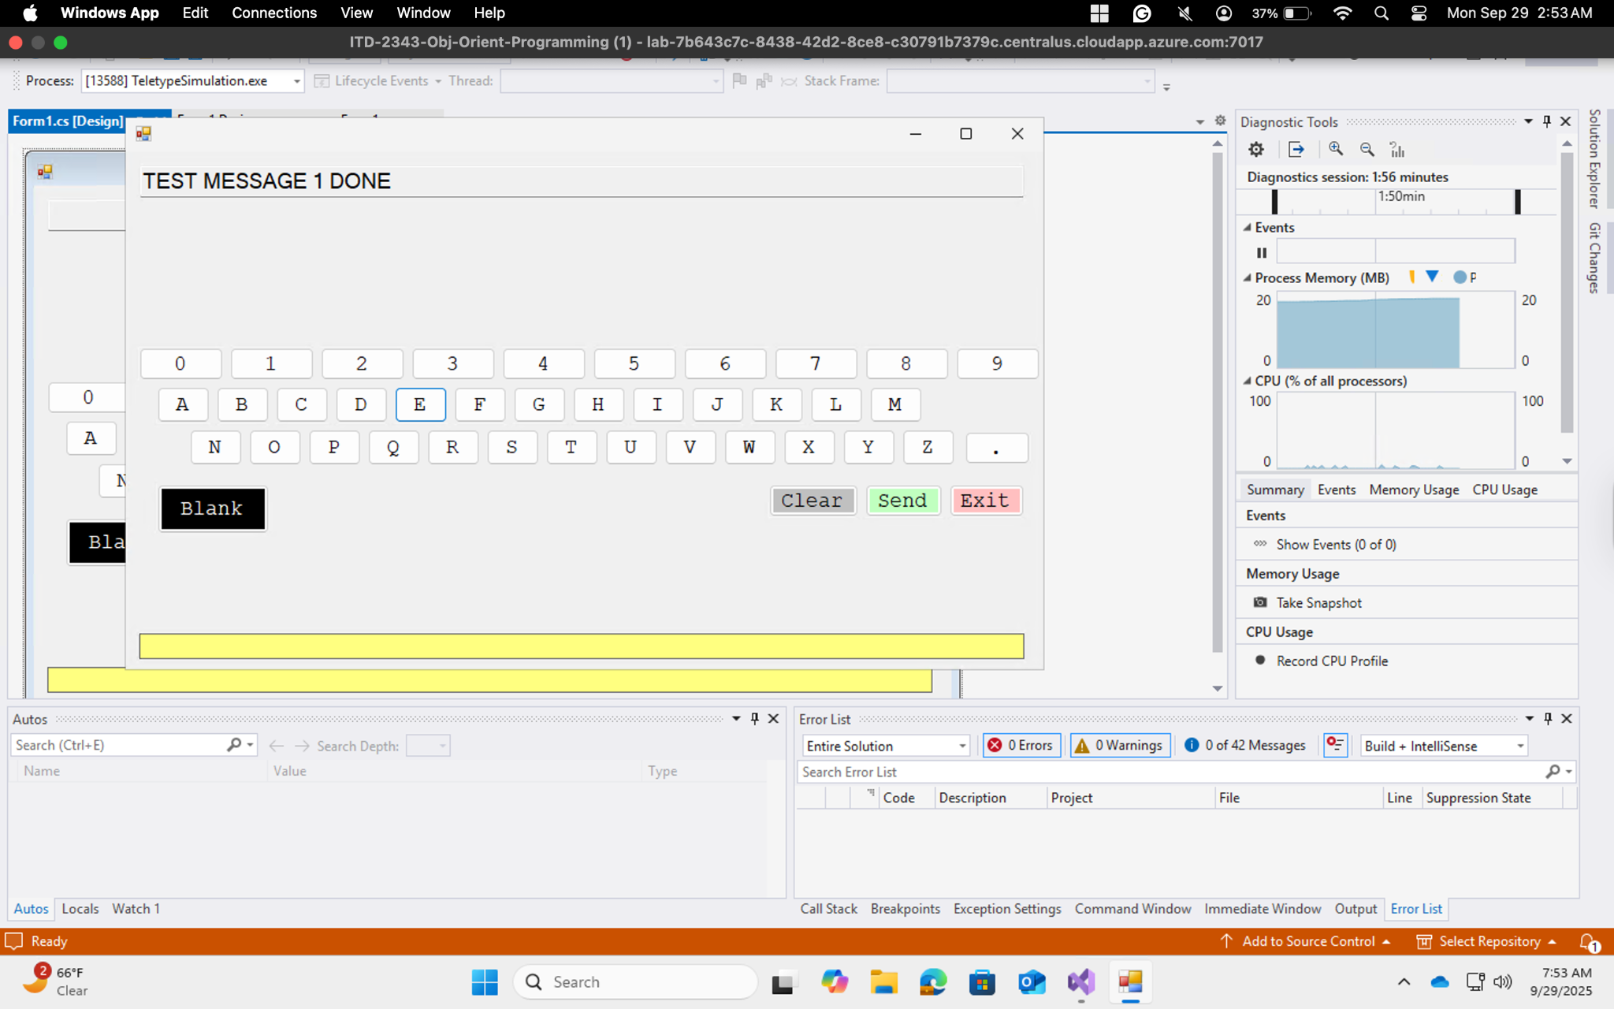

### 5. After Send button

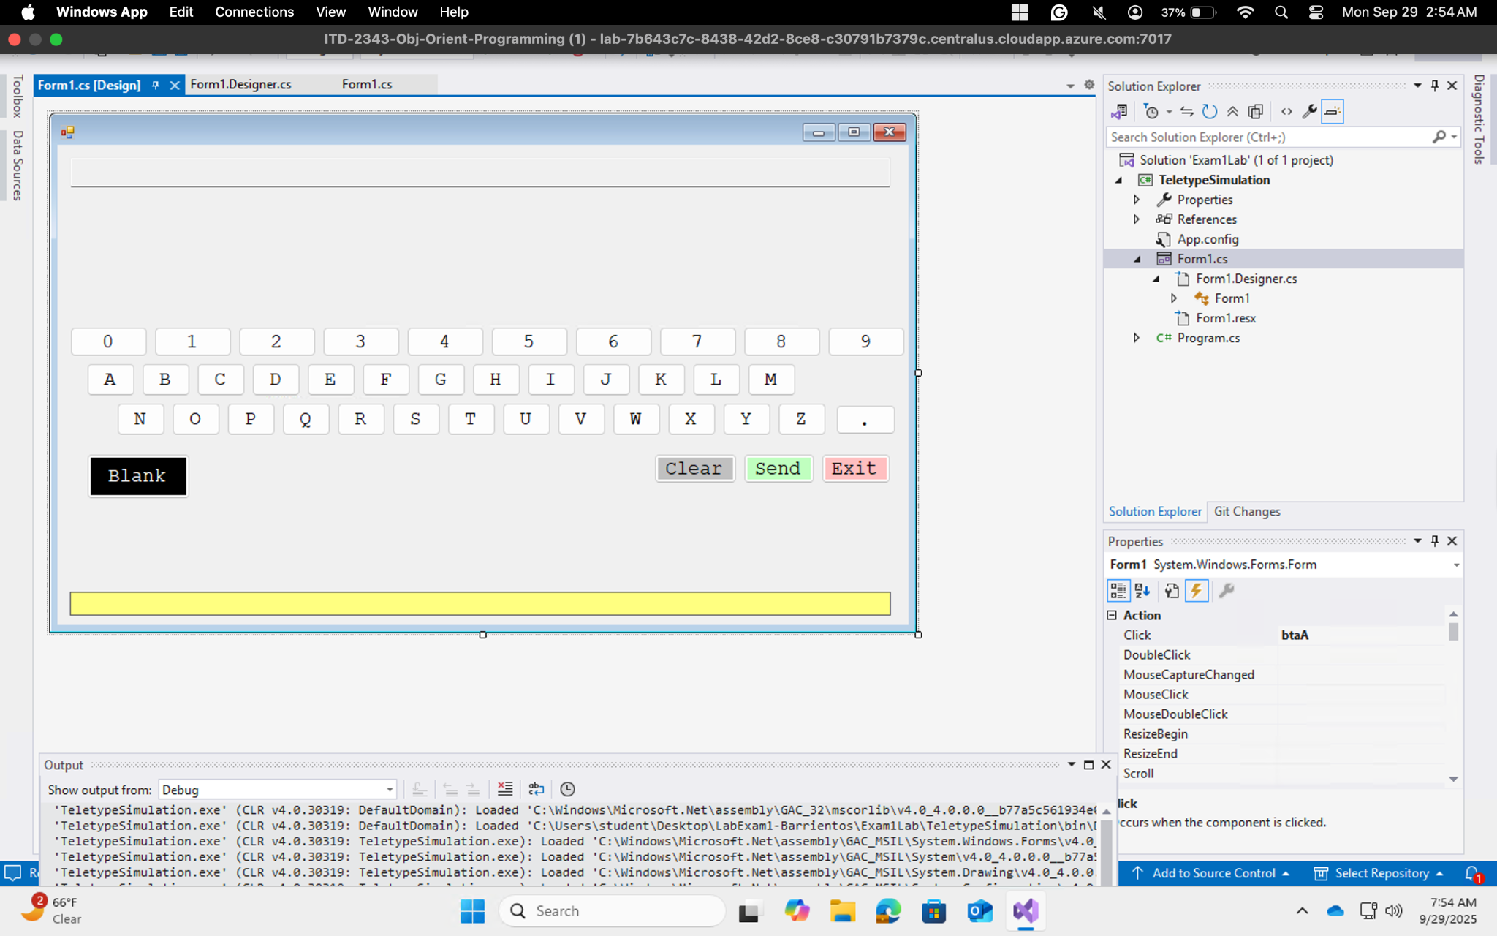

### 6. Clear button in action

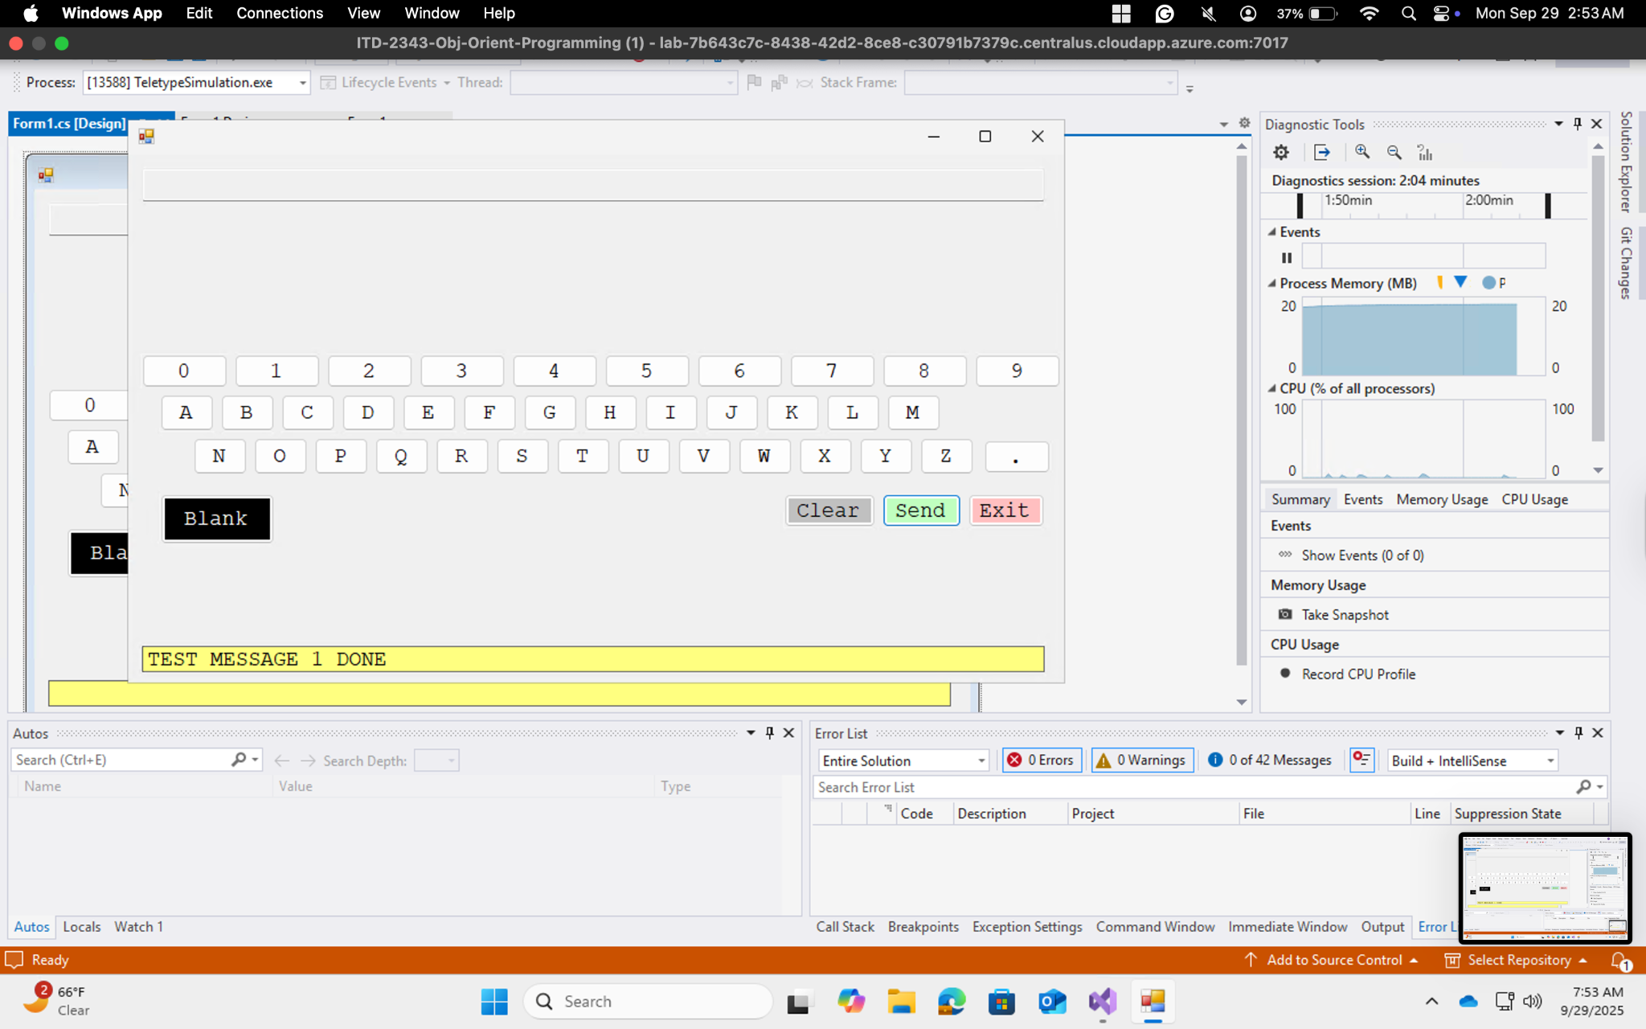

### 7. Exit button

